KOORDINATNI SUSTAV NA PRAVCU
1.
a) 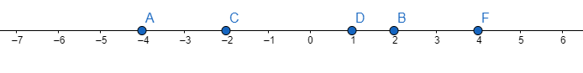
b) 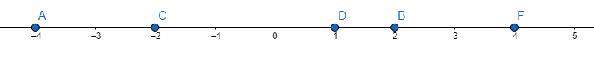
2.
a)
b) 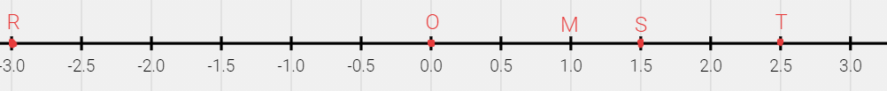

3.
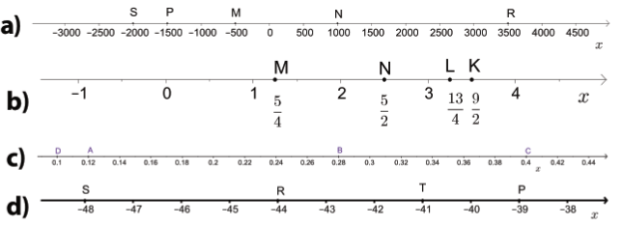

4.
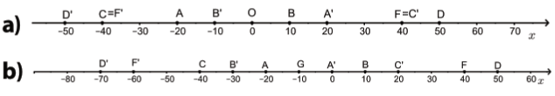
5.
b)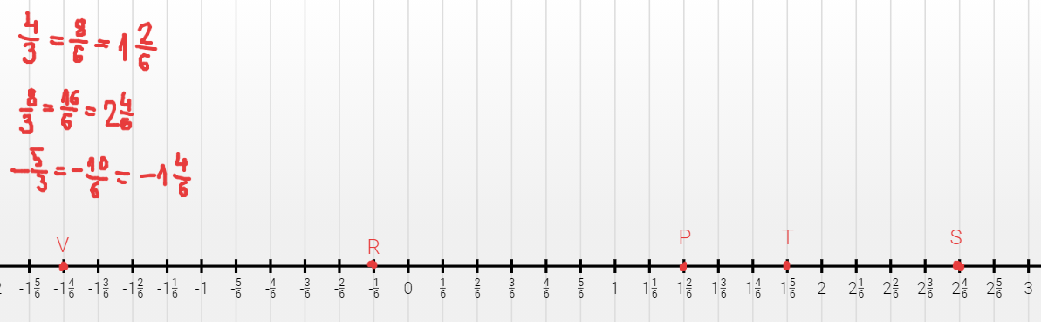
6.
a) A(-9), B(-6),
b) E(1), G(2), H(4), L(7)
c) O(0), E(1), G(2), H(4)
d) B(-6), C(-5), D(-3), F(-1), O(0),E(1),G(2), H(4)

7.
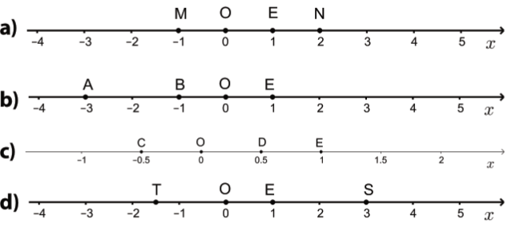
8.
a) U(-2.5), P(-1.5), I(0.5), T(2.5)
b) M(-0.75), R(0.5), N(2.25), A(2.5)
c)$P\left(-2\frac{1}{3}\right), R\left(-\frac{2}{3}\right), I\left(\frac{2}{3}\right), M(2)$
d) U(-1.8), V(-0.4), Z(1.8), T(2.4)

9.
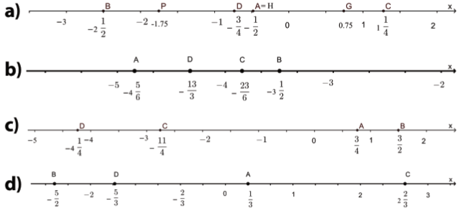

10.
a) H(-2.5), G(-2), E(1), F(4), K(5.5)
b)M(-20.75), A(-20.5), R(-19.5), S(-18.75)

11.
a) $J\left(-2\frac{1}{3}\right), U\left(-1\frac{1}{3}\right), P\left(-\frac{2}{3}\right), I\left(\frac{1}{3}\right), T\left(\frac{2}{3}\right), E\left(1\right), O\left(0\right), R\left(3\frac{1}{3}\right)$
b) $D\left(-2\frac{2}{3}\right), C\left(-2\right), A\left(-\frac{1}{3}\right), B\left(1\frac{1}{3}\right)$
c) B( -2.25), A(-1.75), C(-1), D(-0.75) , F(0.25), E(1), O(0), G(1.75)
d)$M\left(-8\frac{2}{3}\right), A\left(-8\frac{1}{3}\right), T\left(-7\frac{1}{3}\right), K\left(-7\right), I\left(-6\right), C\left(-4\frac{2}{3}\right)$

12.
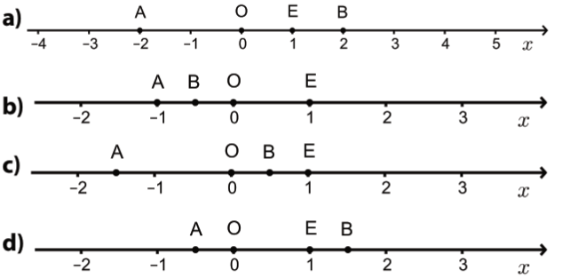
13.
a) F(-2), O(0), E(1), G(3), L(5)
b) D(-3), F(-2), O(0), E(1), G(3), L(5)
c) B(-7), C(-4), D(-3), F(-2), O(0), E(1), G(3), L(5)
d) H(-9), A(-8), B(-7), C(-4), D(-3), F(-2), O(0)

14.
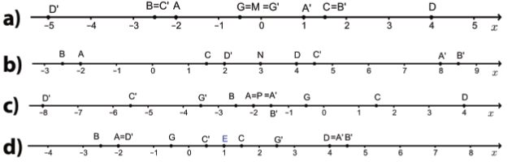
DOPUNSKI ZADACI
15.
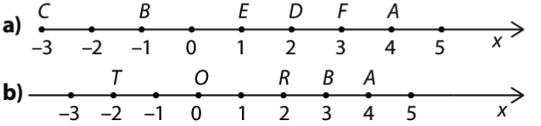
16.
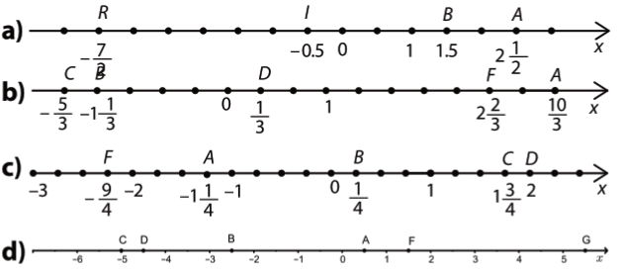

17.
a) F(-500), C(-300),A(-100), B(200), D(400)
b) B(-40), A(-30), F(-10), C(10), D(50)
c) S(-4), L(-2.5), A(-1), T(3.5), K(5.5), I(7.5)
d) B(-2.25), A(-0.25), D(1.5), C(1.75), F(2.75)

19.
a)
b)
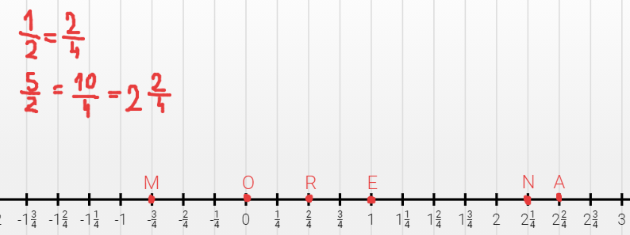
20.
a) d(A,B) = |4|+|-3|=4+3=7
b) d(A,B) = |-12|-|-4|=12-4=8
c) d(A,B) = $\left|-\frac{3}{4}\right|+\left|\frac{5}{2}\right|=\frac{3}{4}+\frac{5}{2}=\frac{3+10}{4}=\frac{13}{4}$
d) d(A,B) = |5.132|+|-4.21|=5.132+4.21=9.342

